NT PHN Acknowledgement Guidelines

NT PHN branding and logos
All providers must use the correct version of the NT PHN logo on any external material promoting a program funded by us. The correct logo is below and can be provided in various formats to suit your use. Please contact our Marketing and Communications team to request the logo, via email: communication@ntphn.org.au or telephone 8982 1041.
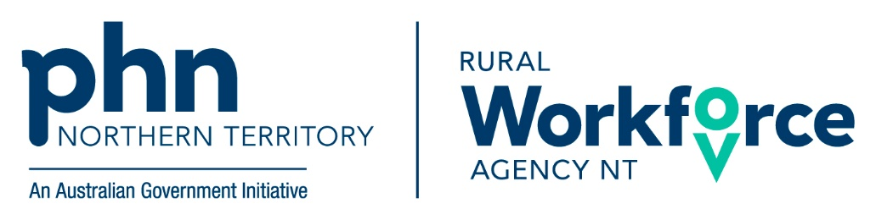

Co-branding
Where you want to use both your logo and the NT PHN logo, there are some requirements around colour and spacing as follows:
- Other branding/logos must be no larger than the PHN Identifier
- Other branding/logos should be positioned to the right of the PHN identifier in a side-by-side configuration. If space will not allow, then the other branding/logos should be stacked below the PHN identifier.
- If a partner organisation is producing the co-branded material, it should be sent back to Northern Territory PHN for review (communication@ntphn.org.au).
- The NT PHN logo must be the minimum size and equal size to any other logos, as outlined below (where practical). If this is not achievable, please talk with the team on other options which may including using the acknowledgement wording instead of a logo:

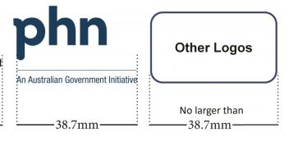
Media releases
We understand that at time you may want to issue a Media Release regarding your program. NT PHN is happy to collaborate on these and asks that all Media Releases are reviewed and approved by us. This is to ensure that NT PHN’s brand and messaging is consistent.
Acknowledgements
The contract provides three statements that can be used to acknowledge NT PHN’s funding:
‘‘This [activity/service] is supported by funding from [insert full PHN name] through the Australian Government’s PHN Program.’
‘This [activity/service] has been made possible by [funding/support] from [insert full PHN name].’
‘This [activity/service] is supported by [Insert full PHN name].’
These can be selected based on the nature of the material you are producing and NT PHN’s Marketing and Communications team are happy to provide advice on which is most suitable.
Events
NT PHN requests that all providers organising an event to promote a program or activity funded by NT PHN, works with us in advance so that we have the opportunity to be involved and can consider:
- Speaking opportunities
- Appropriate branding
- Logo use
- Support NT PHN can provide to you
- Joint promotion of the event including joint media release or advertising.

